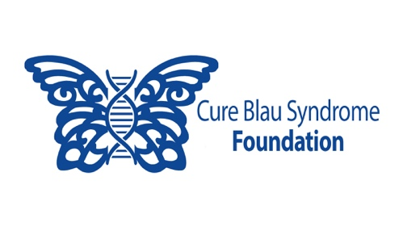

**Sample Application: Blau Ambassador**

Thank you for your interest—we can’t wait to see the impact you’ll make! 💙✨

**Name:** Emma Rodriguez  
**Email:** emma.rodriguez@email.com  
**Date of Birth:** March 12, 2010 **City & Country:** San Diego, USA **School Name & Grade/Year:** Oceanview High School, 9th Grade

**Are you a patient with Blau Syndrome?** No **Does a loved one have Blau Syndrome?** Yes

**Why are you interested in becoming a Blau Ambassador?**I first learned about Blau Syndrome when my little brother was diagnosed with it five years ago. I want to be part of a movement that amplifies the voices of those affected by rare diseases. By becoming a Blau Ambassador, I hope to help spread awareness, educate others, and contribute to meaningful change. I love social media and design, so I believe I can use my skills to make a difference!

**Tell us about your proposed project!**   
For my project, I would like to create an Instagram awareness campaign called #FacesOfBlau. Each post will highlight a different person living with Blau Syndrome, sharing their story, challenges, and hopes for the future. My goal is to post at least one story per month and provide easy-to-understand facts about Blau Syndrome alongside these stories.

**Timeline:**

* Month 1: Research and connect with Blau Syndrome patients/families
* Month 2: Design post templates and draft content
* Months 3-12: Post one story per month and track engagement

**Is there anything else you’d like us to know?**

I feel comfortable with social media as I have managed my personal accounts and can develop engaging reels. I also took a graphic design elective my freshman year in high school which taught me about creating visually appealing and informative content. I am also bilingual (English & Spanish) and would love to create posts in both languages to reach a wider audience! Also, my school requires I complete 30 hours of service to my community so I would like to use this requirement to help the foundation.